# Create feedback – foss4smes:

# Option 1(More generic):

Step 1: We go to the unit, we enable editing (top right corner) and we press “Add an activity or resource”.

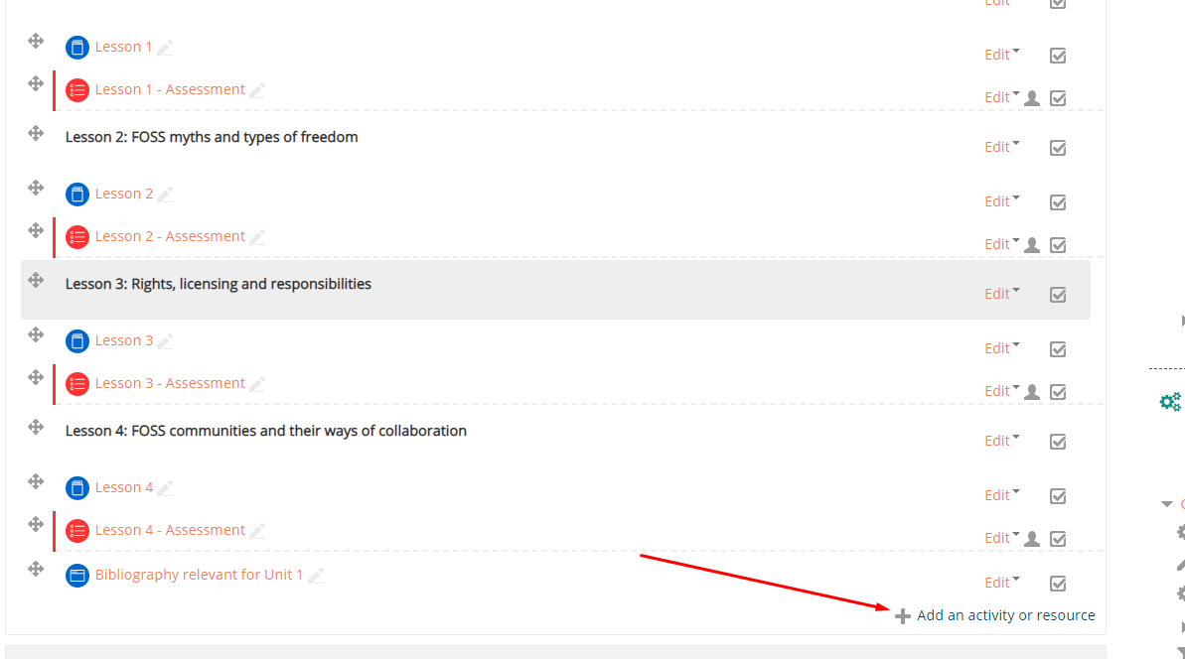

We select “Feedback” and we press add.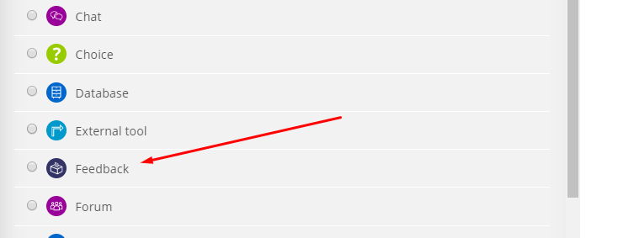

We type a name and we select User’s Name will be logged and shown with answers. Otherwise we will not be able to know how answered the feedback. We also type the completion message which will be displayed after the user submits the feedback. We also select show activity as complete when conditions are met and we make sure that the first two checkboxes are selected.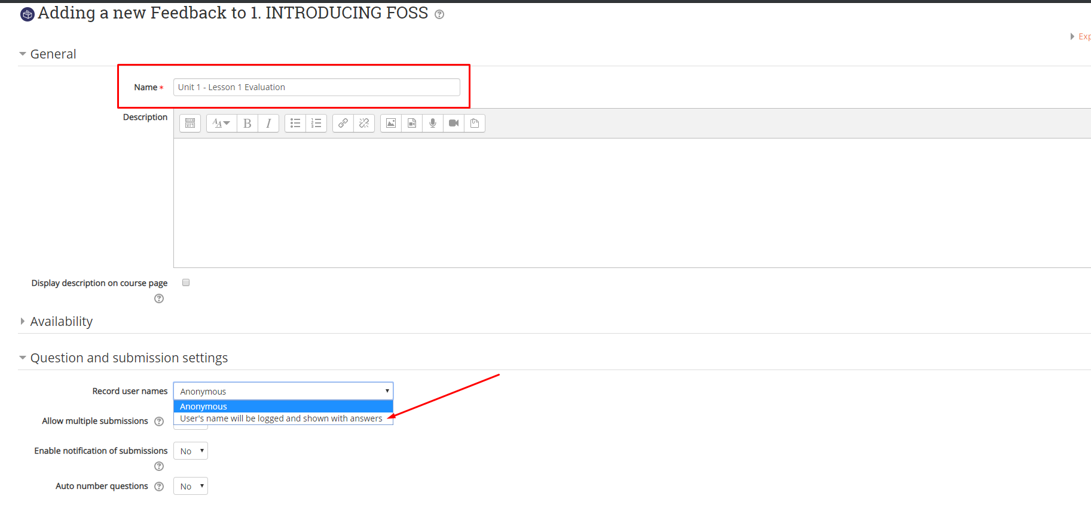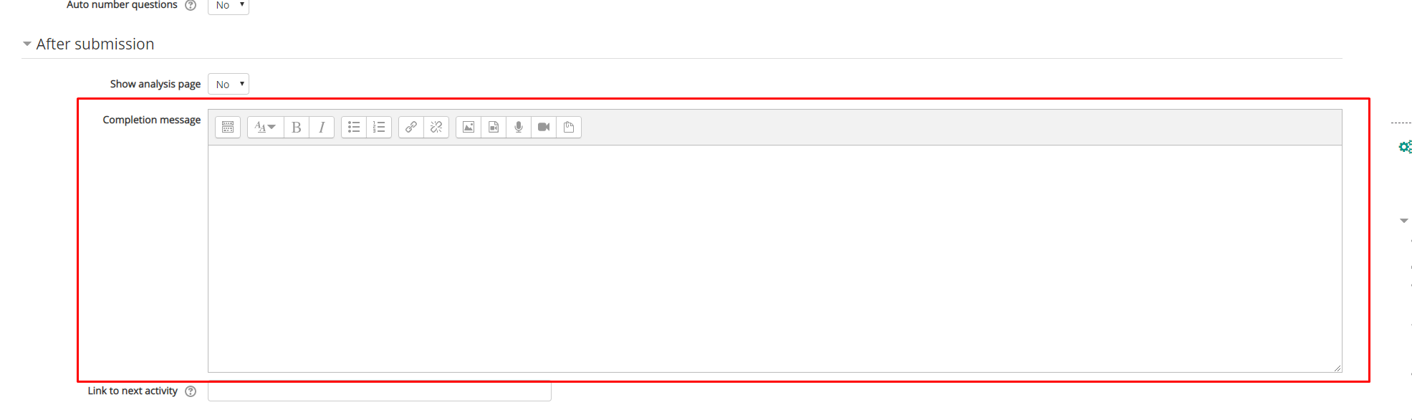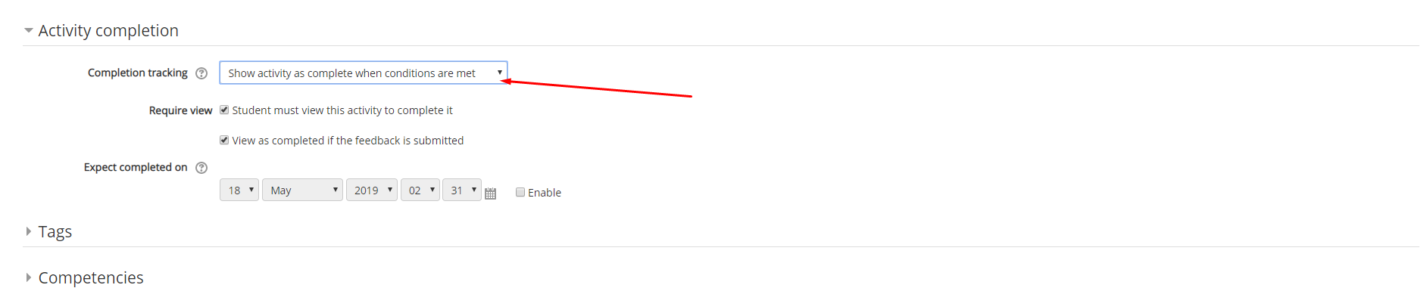

In the page that will be opened if we want to simply add the message: Rate your existing knowledge on these lesson topics, we go to the templates tab and select the RateExisitngKnowledge Template. Then we select delete old items and select save changes.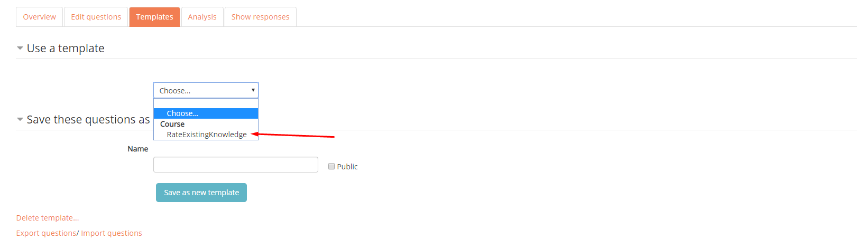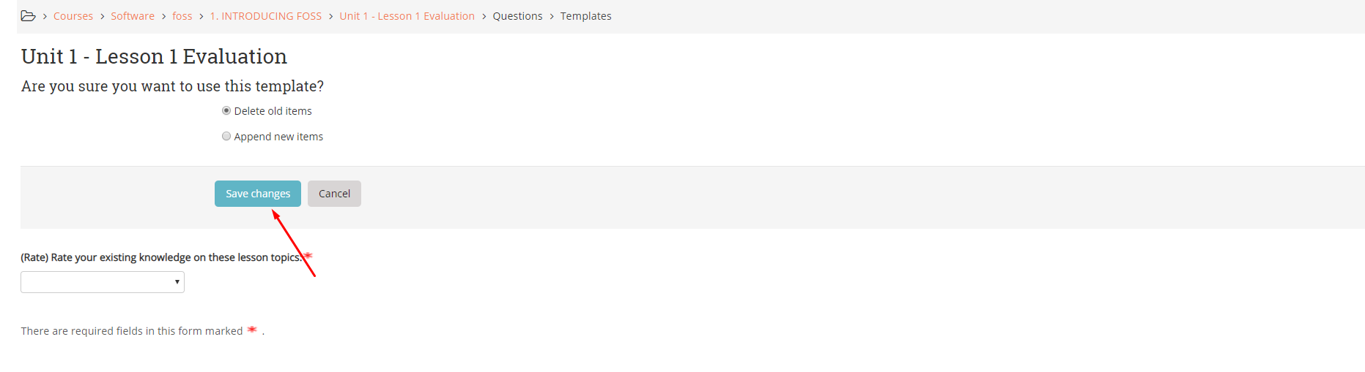

Otherwise if we want something new we go to the edit questions tab, we select add question and choose the type of question. 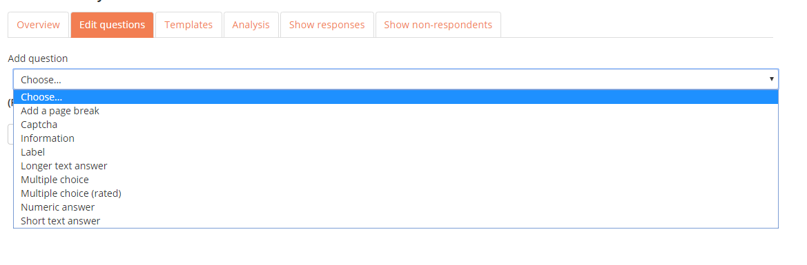

An example for a Multiple choice:

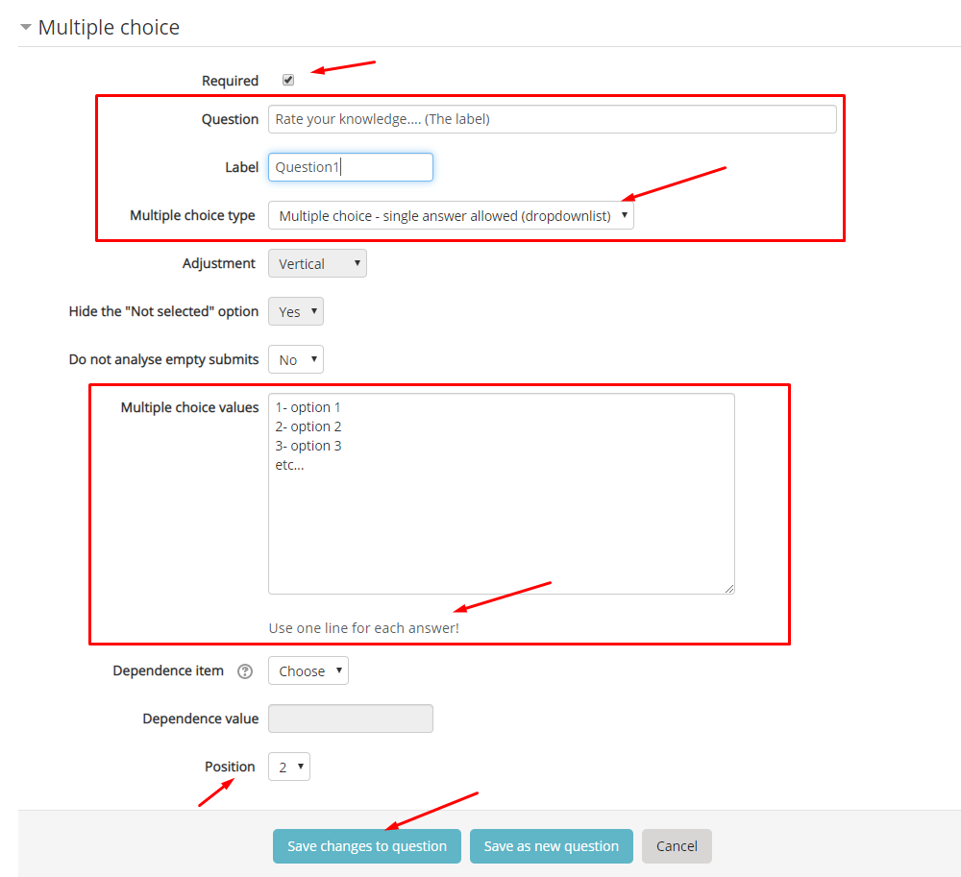

# Option 2(duplicating):

We duplicate an existing feedback and change the name. THIS WILL BE EXACTLY THE SAME QUESTIONS AND TEXT AFTER ANSWERING IF WE DON’T CHANGE IT

We press duplicate and edit the name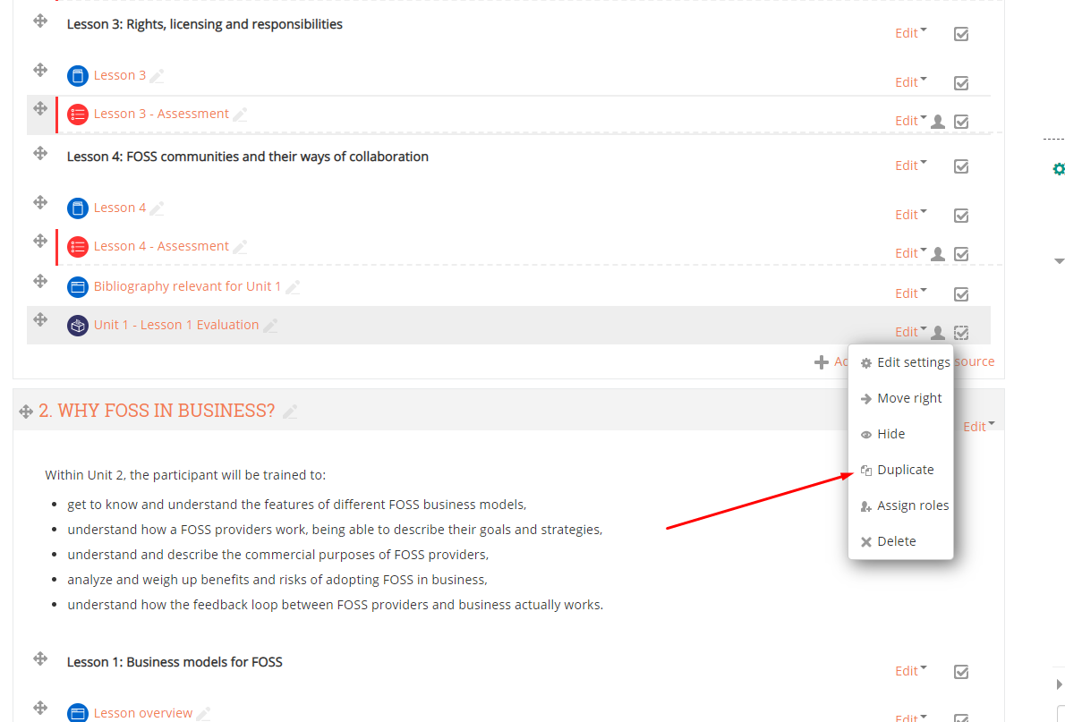

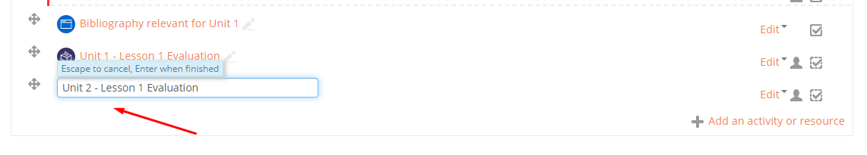

We drag and drop it to the position we want it.