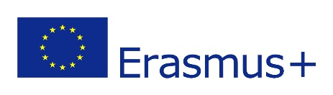

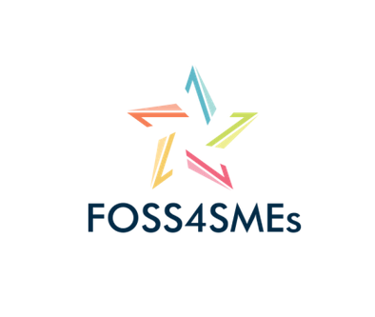

**Project title: Free Open Source Software for SMEs**

Project activity:

Licencing Strategy

as part of the

Exploitation Plan (A13)

**Version: 0.1**

**Berlin, Germany**

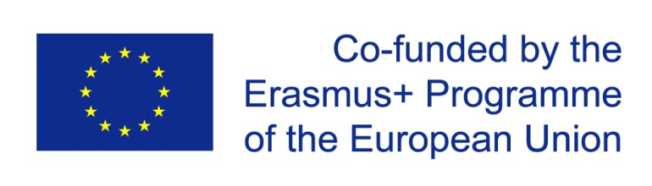

The European Commission’s support for the production of this publication does not constitute an endorsement of the contents which reflects the views only of the authors, and the Commission cannot be held responsible for any use which may be made of the information contained therein.

**CONTEXT**

|  |  |
| --- | --- |
| **Grant agreement** | 2017-1-EL01-KA202-036112 |
| **Programme** | Erasmus+ |
| **Key action** | Cooperation for innovation and the exchange of good practices |
| **Action** | Strategic Partnerships |
| **Project acronym** | FOSS4SMEs |
| **Project title** | Free Open Source Software for SMEs |
| **Project starting date** | 01/10/2017 |
| **Project duration** | 24 months |
| **Project end date** | 30/09/2019 |
| **Project Activity (A)**  **Intellectual Output (IO)**  **Multiplier Event (E)**  **Short-term joint staff training events (C)** | A13 – Exploitation Plan |
| **Deliverable title** | Exploitation Plan |
| **Nature of deliverable** | REPORT |
| **Dissemination level** | CONFIDENTIAL |
| **Due date of deliverable** | M3 |
| **Actual date of deliverable** | xx/xx/2018 |
| **Produced** | P5- Free Software Foundation Europe |
| **Reviewed** |  |
| **Validated** |  |

Table of Contents

Glossary of acronyms and abbreviations 5

1. Introduction 6

2. Basic Principles of Licencing Choice 6

2.1. Default Licence 7

2.2. Exceptional Cases 7

## Glossary of acronyms and abbreviations

|  |  |
| --- | --- |
| **FOSS4SMES** | Free and Open Source Software for Small Medium Enterprises |
| **PM** | Project Manager |
| **PC** | Project Coordinator |
| **MC** | Management Committee |
| **AB** | Advisory Board |
| **QM** | Quality Manager |
| **FOSS-BU** | Free and Open Source Software – Business User |
| **ATL** | Atlantis Engineering S.A. |
| **Dlearn** | EUROPEAN DIGITAL LEARNING NETWORK |
| **SKUNI** | University of Skövde |
| **OFE** | OpenForum Europe |
| **FSFE** | Free Software Foundation Europe |
| **DIT** | Dublin Institute of Technology |
| **VET** | Vocational Education and Training |
| **ECVET** | European Credit System for Vocational Education and Training |
| **NA** | National Agency |

### Introduction

This document serves as a statement and mutual agreement of the partners of the FOSS4SMEs consortium regarding the strategy for further dissemination and exploitation of the project's results. It is part and starting point of the larger Exploitation Plan which is subject to being drafted at this stage. Its goal is to define guidelines for setting the intellectual property rights of created materials throughout the project time to guarantee public access.

The FOSS4SMEs project educates about the benefits of Free and Open Source Software for businesses: cooperation, flexibility, innovation and many more. As project partners we are convinced that these principles should also apply to our work. We want to allow people to use, study, share and improve the knowledge we gained. Therefore, the materials we create will be released under a licence which supports these goals.

### Basic Principles of Licencing Choice

It is crucial to define a proper licence for the e-learning courses and further documents which are going to be crafted. By default all materials would be subject to normal copyrighting which makes it harder for others to use and reuse it. As with FOSS, the licencing should contain the four essential freedoms:

1. The materials can be used for any purpose, no matter if for personal, educational or commercial gain.
2. The materials can be studied. This freedoms plays a larger role for software which is often intransparent from the outside. But also our learning courses should allow people to inspect their structure and ease the execution of the other freedoms.
3. The materials can be shared. Users should be allowed to forward the learning documents to their friends, students or colleagues.
4. The materials can be improved and edited. Any entity should be allowed to modify the courses, for instance to extend them, fix mistakes or update their content.

As the European-wide FOSS4SMEs project, we have some additional preferences:

* The licence shall be easy to adapt and compatible with other common FOSS and open knowledge licences. This allows people and businesses to bundle their knowledge with the consortium's and reach a huge audience.
* The licence shall require entities which republish the FOSS4SMEs materials, no matter if modified or not, to state its original authors. As a publicly funded project we consider it important to allowing reuse on the one hand, but stating the source of creating on the other.
* The licence shall require republishing entities to use a licence with the same provisions. This can either be the same licence or a compatible one. This way, all freedoms and also this very same condition will always be preserved. In the FOSS world, such a principle is called copyleft.

## Default Licence

As with Free Software, there is a considerably large range of licences which fit these requirements with different scopes and conditions involved. With CC BY-SA 4.0 International, we decide to prefer one specific licence. It is one of Creative Commons licenses which is considered compatible with the most important FOSS licences, for example GNU GPL 3.0[1]. It is also translated to a lot of languages which makes it easy for non-English speakers to understand its essence. Another advantage is its wide spread in many areas which lowers thresholds for people and institutions to reuse the FOSS4SMEs materials.

The key elements of CC BY-SA 4.0 are:

* Free to share: copy and redistribute the material in any medium or format
* Free to adapt: remix, transform, and build upon the material for any purpose, even commercially
* One must give appropriate credit, provide a link to the license, and indicate if changes were made. One may do so in any reasonable manner, but not in any way that suggests the licensor endorses one or one’s use (Attribution).
* If one remixes, transforms, or builds upon the material, one must distribute one’s contributions under the same license as the original (Share Alike).
* No additional restrictions: one may not apply legal terms or technological measures that legally restrict others from doing anything the license permits.

See the [official website](https://creativecommons.org/licenses/by-sa/4.0/) for more information on CC BY-SA 4.0 and the full licence text.

## Exceptional Cases

However, we also allow us to re- or dual-licence specific material under the very permissive licence CC0 1.0. Using this licence waives practially all copyrights and dedicates the work to the public domain. This can be possible for audiovisual files like spoken text, pictures or videos under certain conditions when reusers and remixers of such material have very convincing reasons that the BY[2] or SA[3] requirement actively hinders the material's usage. These exceptions have to be discussed with all partners taking the different options and effects into account.

More informaton on CC0 can be found on [its website](https://creativecommons.org/publicdomain/zero/1.0/).

With these considerations taken into account, we strongly believe that it improves the dissemination and exploitation of the FOSS4SMEs project results. Our actions also are showing other people, businesses and organisations that we are convinced of the FOSS principles. Insofar, our active choice is also a role model and positive example for others in the field, especially educational institutions.

1. Can you provide here a definition of this or a link where the reader can find more information on this?
2. Can you provide here a definition of BY or a link where the reader can find more information on what this means?
3. Can you provide here a definition of SA or a link where the reader can find more information on what this means?