These are the credentials I use to log into the survey site:

Webpage: <https://survey.fsfe.org/index.php/admin/index>

Username: katerina

Password: UrqITUORIfsT

Once you entered the survey click here:

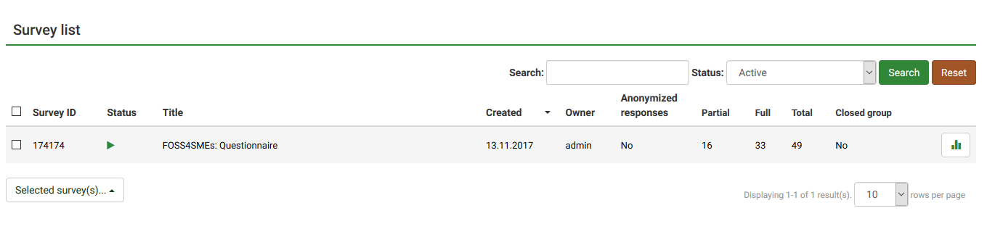

Then click here:

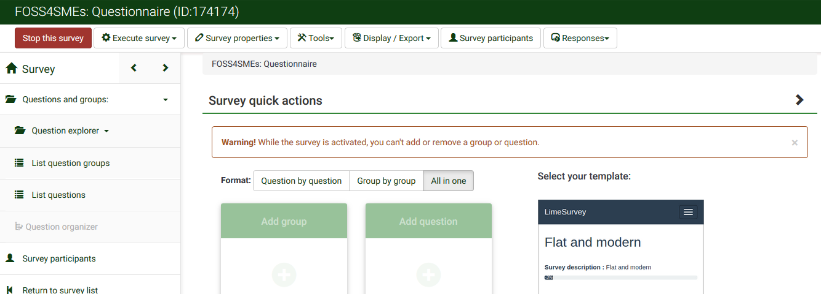

Then click here:

Responses and statistics

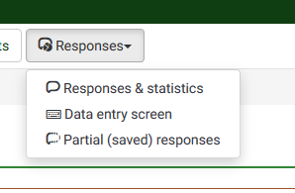

Then select the language of the responses:

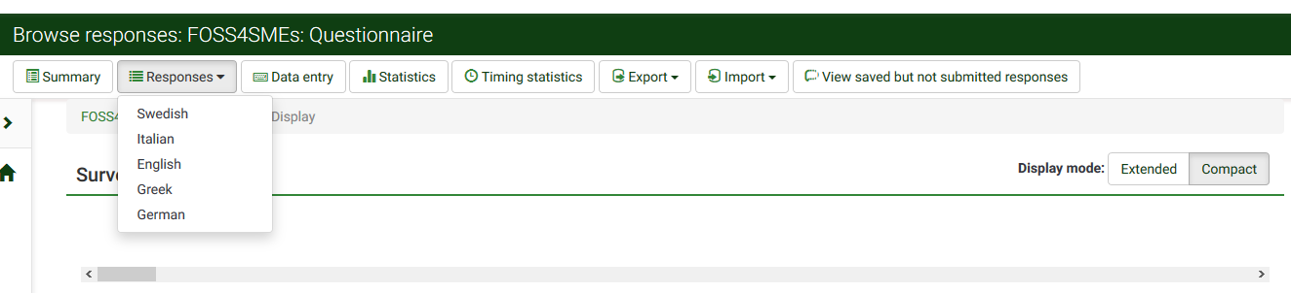

Then you have to scroll down and then scroll to the right to see you has answered the survey:

